**Start**

**Start (Pre-A1)**

**Let’s Go Camping!**

***Look at the picture and read. Choose the correct answer for questions 1-12.***

Isaac, Luna and Aster are hiking. Their friend Chris is waiting for them at the campsite.

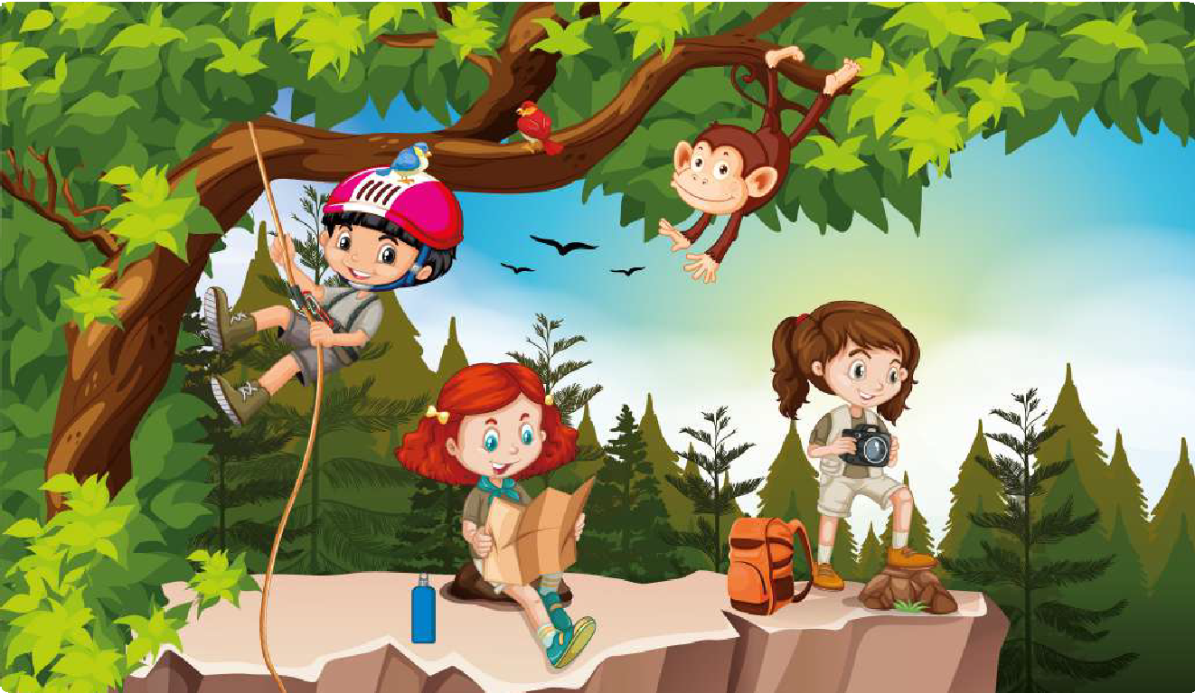

Look!

There’s Chris!

Luna

Aster

Isaac

We’re very close to our camp.

I can swing too!

Woohoo!

1. **The children are … in the mountains.**
   1. running **B)** hiking **C)** biking **D)** playing
2. **Luna is reading a …**
   1. **B) C) D)**



book.



sign.

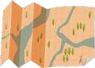

map.



newspaper.

1. **Aster is holding … in her hands.**
   1. **B) C) D)**



a camera



a phone

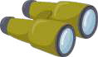

binoculars



a radio

1. **Isaac and a … are swinging from the tree.**
   1. **B) C) D)**



bird.

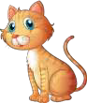

cat.



raccoon.



monkey.

**Start**

1. **Luna is sitting on a …**
   1. **B) C) D)**



plank.

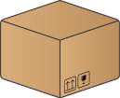

box.



rock.

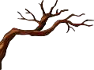

branch.

1. **Luna says that they are … their campsite.**
   1. near **B)** far from **C)** at **D)** on
2. **Isaac is wearing a red and white …**
   1. **B) C) D)**

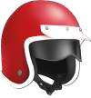

helmet.



hat.



bandana.



headband.

1. **There is an orange backpack … Aster.**
   1. next to **B)** behind **C)** above **D)** under
2. **There are … birds in the picture.**
   1. **B) C) D)**



three



four



five

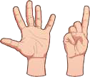

six

1. **Luna has a … water bottle.**
   1. **B) C) D)**



blue



green



yellow



black

1. **Chris is …**
   1. at the campsite. **B)** at home. **C)** on the tree. **D)** hiking alone.
2. **There is a bird … on Isaac’s head.**
   1. sleeping **B)** flying **C)** eating **D)** standing

***Look at the picture and read. Choose the correct answer for questions 13-25.***

Isaac, Luna and Aster are now at the campsite with Chris.

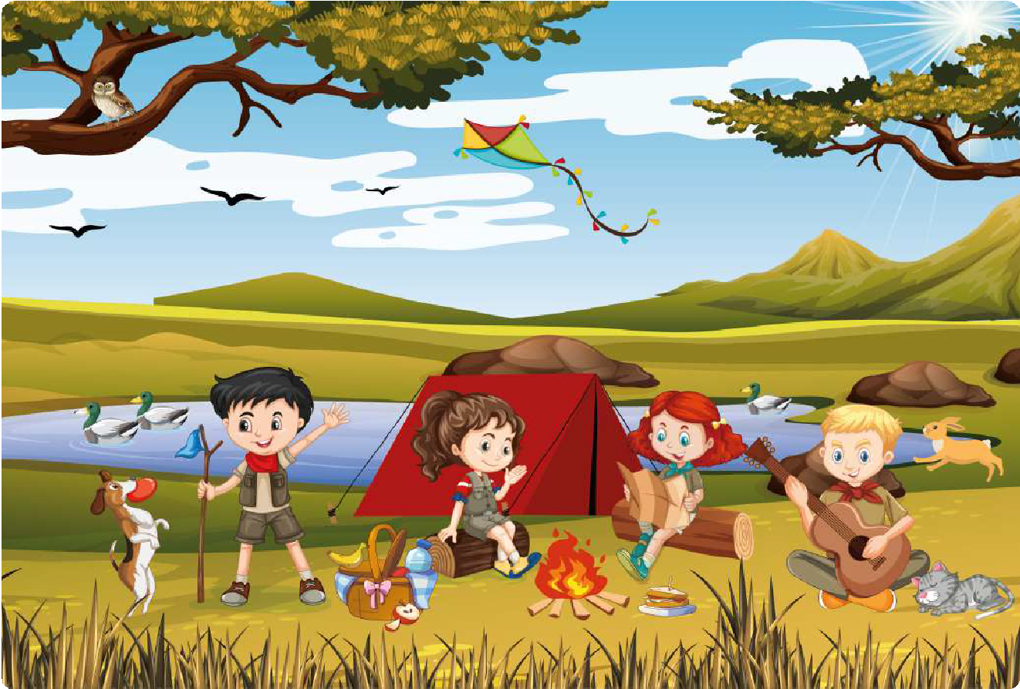

Let’s have some snacks.

One more song!

I’ll have a sandwich!

Spock wants to play fetch!

1. **The children are next to a red …**
   1. **B) C) D)**

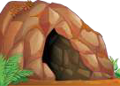

cave.

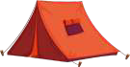

tent.



house.

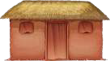

hut.

1. **Luna wants to …**
   1. play. **B)** drink. **C)** eat. **D)** dance.
2. **Chris is playing the …**
   1. **B) C) D)**

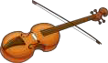

violin.

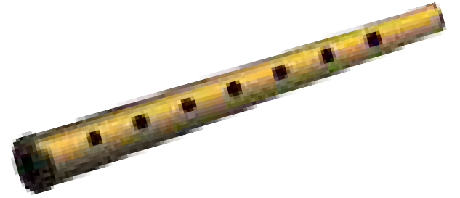

flute.



drums.

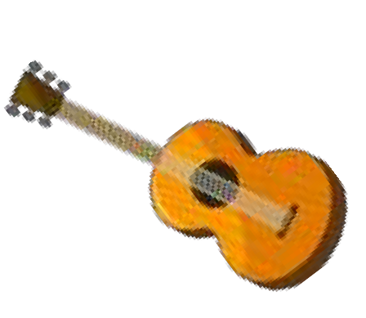

guitar.

1. **The rabbit is …**
   1. sleeping. **B)** flying. **C)** running. **D)** eating.
2. **Aster and Luna are sitting … the fire.**
   1. on **B)** at **C)** in **D)** by
3. **The … are swimming in the pond.**

**Start**

* 1. frogs **B)** fish **C)** ducks **D)** children

1. **Chris has … hair.**
   1. **B) C) D)**

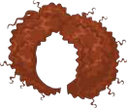

curly



red

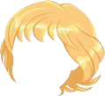

blond



dark

1. **Who wants to play with the ball?**
   1. **B) C) D)**



The dog.



The rabbit.



Isaac.

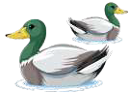

The ducks.

1. **What can you not see in the sky?**
   1. **B) C) D)**



A kite.

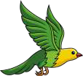

A bird.



A cloud.



A plane.

1. **Isaac is holding a blue …**
   1. **B) C) D)**

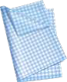

napkin.



flag.



scarf.



cap.

1. **The cat near Chris is …**
   1. **B) C) D)**

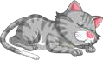

sleeping.



eating.

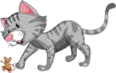

playing.



sitting.

1. **There is ... in the tree.**
   1. **B) C)**

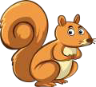

a squirrel

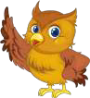

an owl

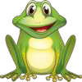

a frog



**D)**

**G**

**N**

**__**

**L**

**A**

**G**

**N**

**I**

**S**

an apple

1. **Fill in the missing letter in the following word.**
   1. A **B)** I **C)** U

**D)** O